Lab 4: BJT

Subject: Semiconductor Devices



Name: Ahmed Sabry Hamza Eldeeb

ID: 19015258

Department: Communications

Section: 1

The Ebers Moll model:

The Ebers-Moll model and the Gummel-Poon model are two commonly used models used to describe the behavior of a bipolar junction transistor (BJT). Both models are based on the same physical principles and are equivalent in terms of the equations used to describe the behavior of the BJT.

The main difference between the two models is that the Ebers-Moll model focuses on the current-voltage (I-V) characteristics of the BJT and uses a large-signal analysis approach to describe the behavior of the device. This model is used to describe the DC characteristics of the BJT ***while*** The Gummel-Poon model on the other hand, focuses more on the small-signal characteristics of the BJT and uses a small-signal analysis approach to describe the behavior of the device. This model is used to describe the AC behavior of the BJT.

In short, the main difference between the Ebers-Moll model and the Gummel-Poon model is that the former is used to describe the DC behavior of the BJT while the latter is used to describe the AC behavior of the BJT.

BJT Device Model:

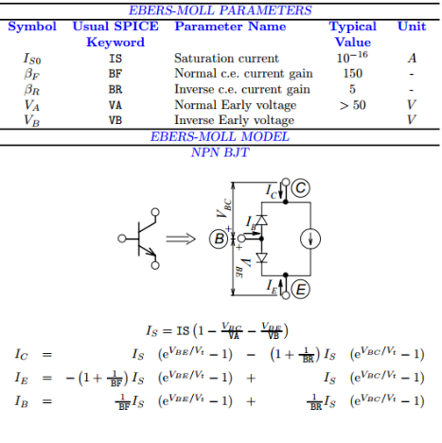

Procedures:

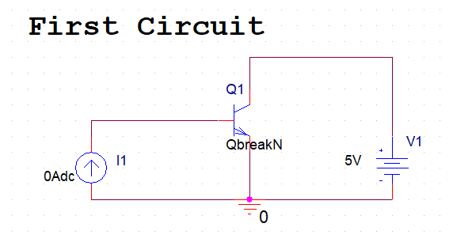1- Connect the circuit as shown in the figure below, using QBREAKN device from the BREAKOUT library.

2- Place a current probe on the collector of the BJT.

3- Create a simulation profile using DC sweep on I1 (0, 10mA, 2.5mA) + parametric analysis on Is with 1pA and 10pA.

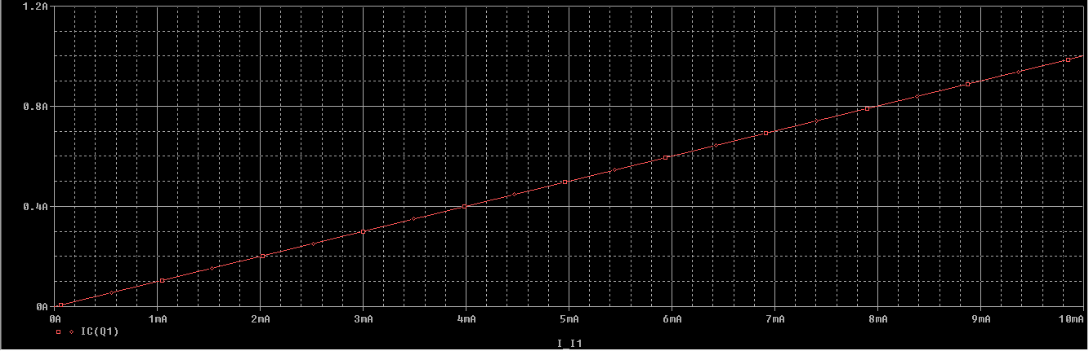

4- Is there a change between the two curves, why ? What does the slope of the curve represent ?

Comments:

* As we can see that we got the same graph for both values of Is so that VBE will decrease as Is increases to maintain BFvalue constant as it is our current gain and **the slope** of the curve.



5- Cancel the parametric sweep.

6- Edit pspice model with Is = 1p.

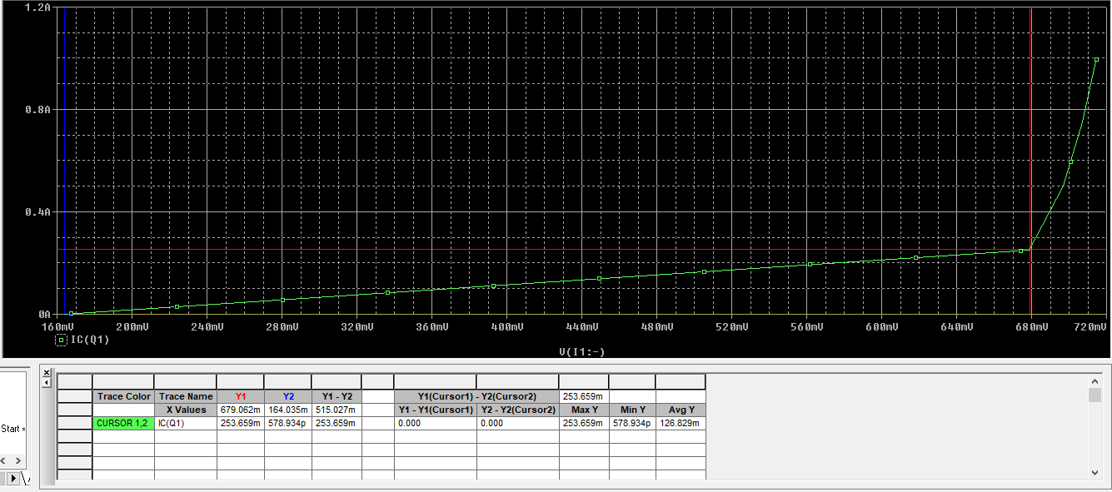7- Run DC sweep, on the plot, choose Plot >> Axis settings >> X axis >> choose V(I1: - ).

8- Record the turn on voltage, what does the slope of the curve represent ?

Comments:

* The turn on voltage = **680mV**
* The slope of the curve = IC / VBE = alpha / Ri

9- Repeat the previous steps for Is = 10p , record the turn on voltage, explain the change.

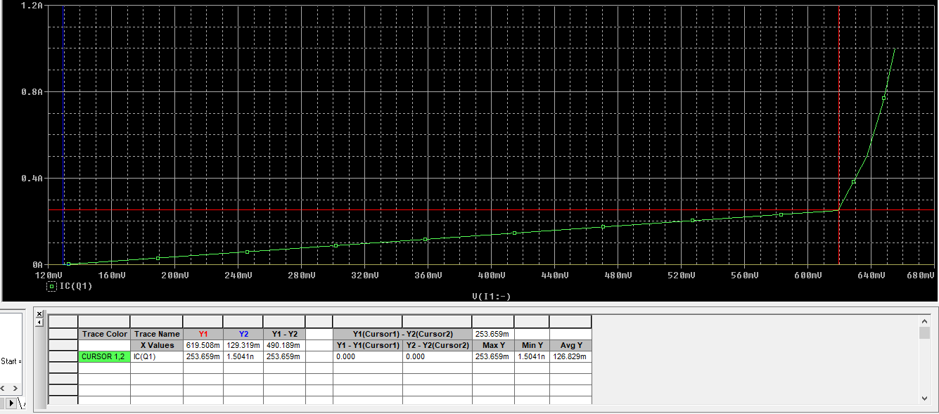

Comments:

* We can see that turn voltage decreased till **620mV** when Is increases which proves our previous observation in step 4 of maintaining BF as constant.

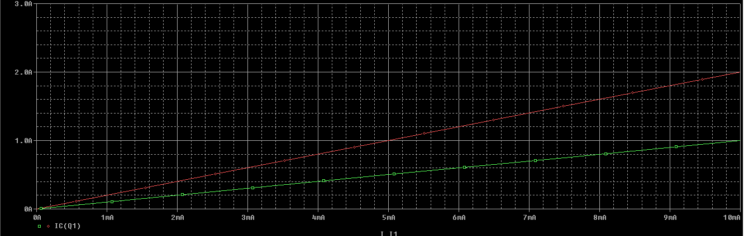10 - Repeat steps 3 and 4 but with the parameter BF= 100 and 200. Comment on the results.

Comments:

* We got two different graphs as BF increases, the slope does so.

11- Repeat the steps 5 till 9 with BF = 100 and BF = 200, comment.

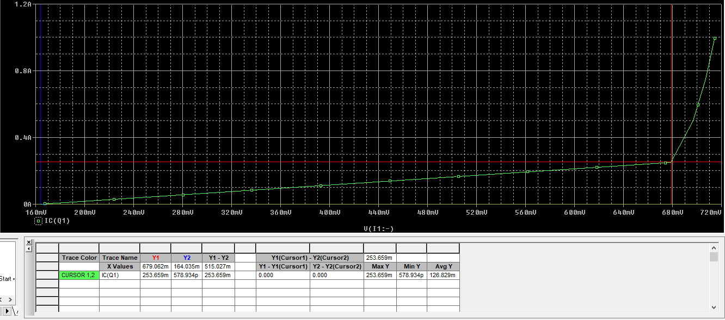Is=1p, BF=100

* 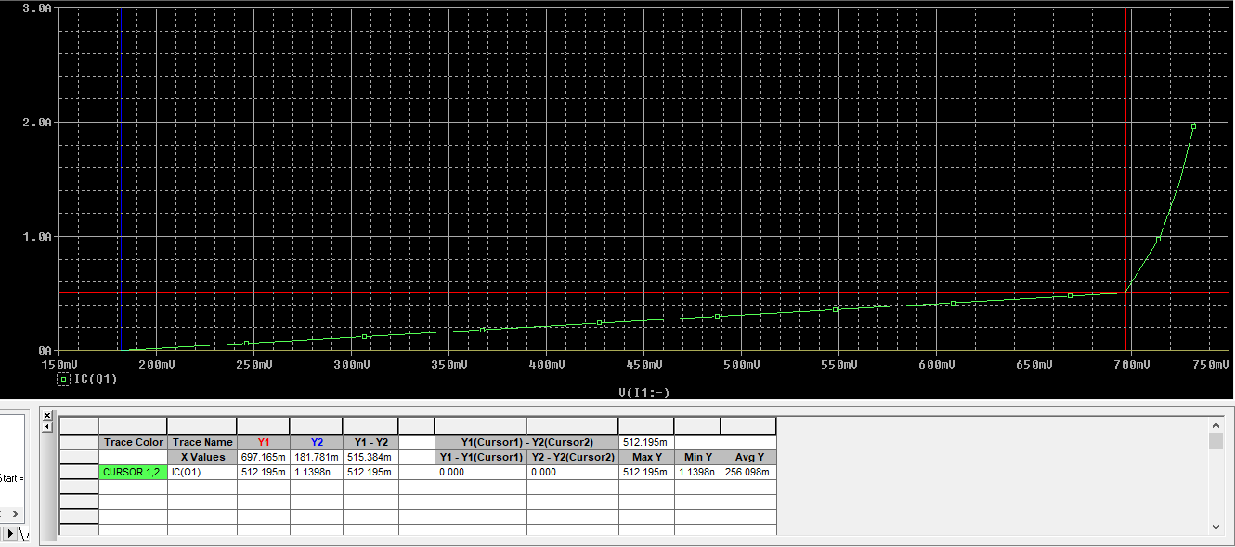Notice that we got the same graph as before (VBE = 680mV) and the max current is 1A.

Is=1p, BF=200

* Now we have a higher VBE up to 700mV as we increased the current gain therefore, we have a higher max current equal to 2A

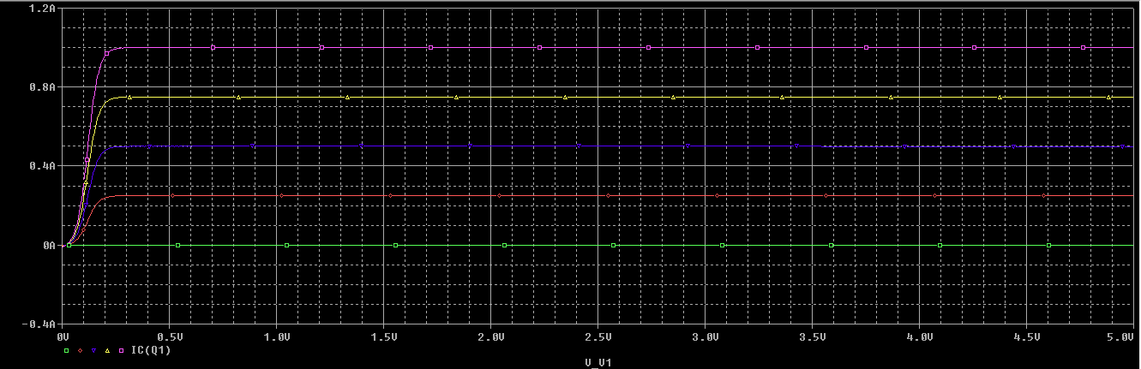12- Using the same circuit, make the primary sweep on the voltage source and the parametric on the current source with BF = 100.

I-V chars of BJT

Comments:

* As IB increases by increasing the current source, then we have a higher output current IC till it reaches 1A as BF=100.

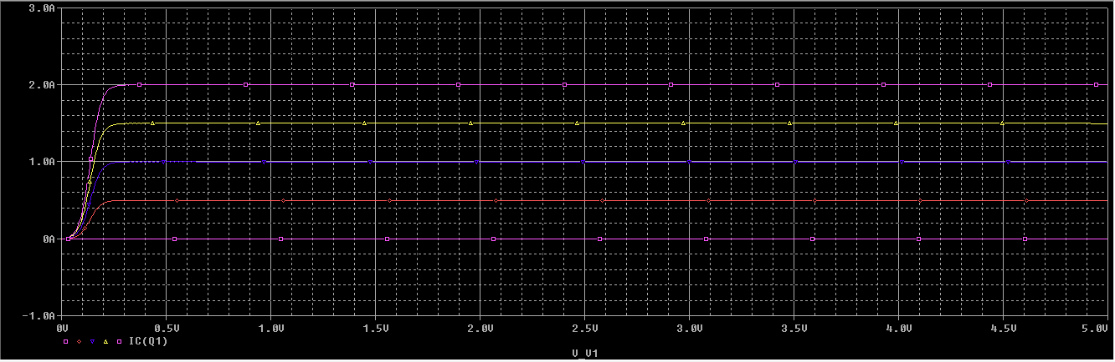13- Repeat the step for BF = 200, comment on the results.

Comments:

* Everything is the same but ***shifted up***.

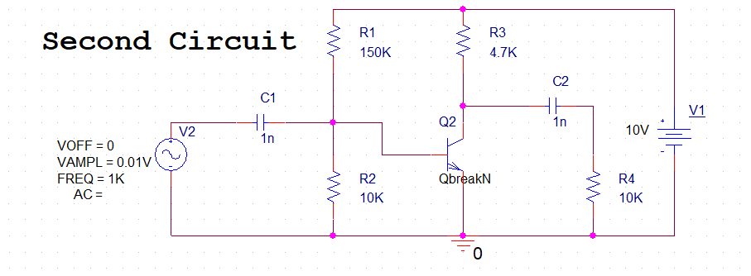14- Connect the circuit as shown in the following figure:

15- For Is = 1pA and BF = 100, run transient simulation and plot the output, then change BF to 200 and explain the reason for the change in the results.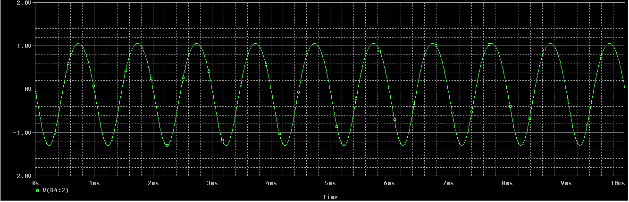

Output Voltage

* 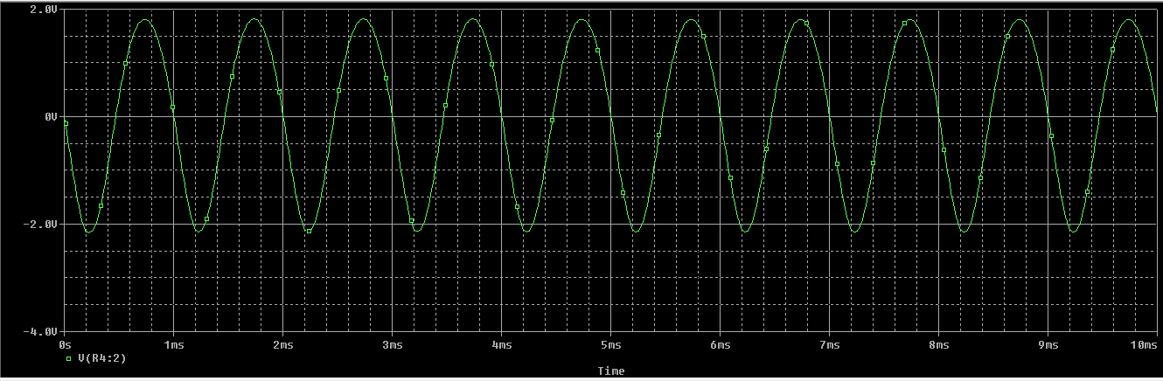Oscillating between about **1.05V and -1.2V**
* Oscillating between about **1.8V and -2.1V** during more gain (reasonable)!

16- Replace the sine source with an AC source.

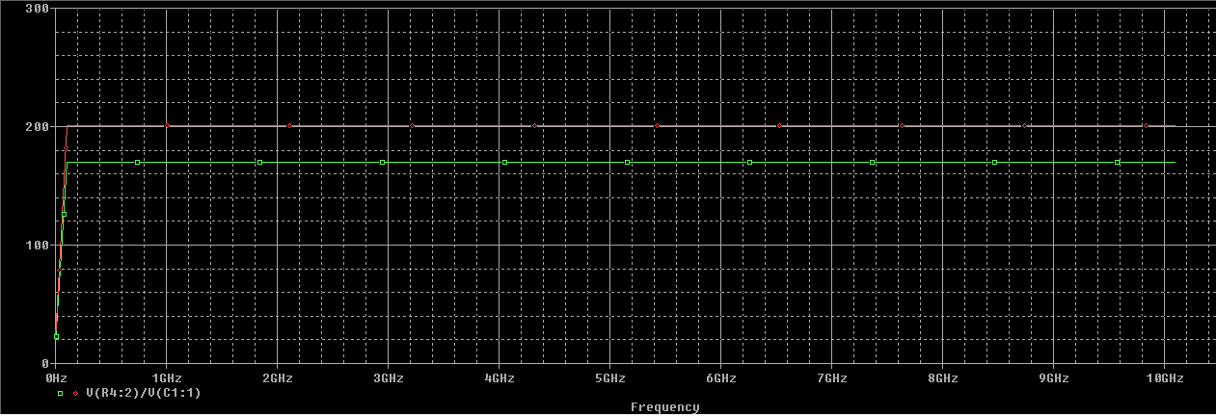17- Run AC sweep from 10Hz to 10GHz + parametric sweep with VA = 1000V and VA = 20V.

19- Explain the change in the gain due to the change in VA, also explain the change in the gain with the frequency.

Comments:

* In the first part of the graph, we could see that in **lower frequencies** there is an effect of **coupling capacitors** on the gain of the BJT, while in higher frequencies this effect has gone as those caps behave as short circuits (lower impedance).
* Notice that having higher VA (early voltage) causes higher current gain depending on these relations:

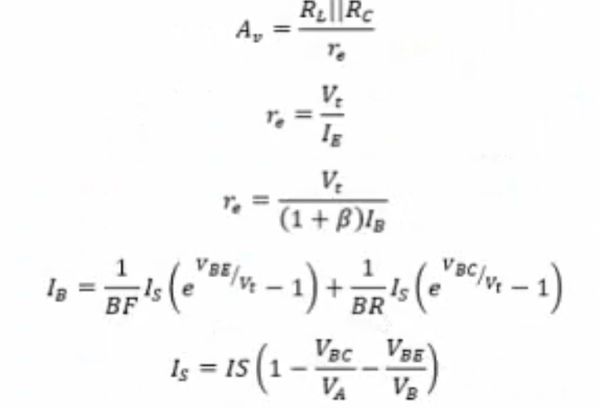

* VA , then Is
* Is , then IB
* IB , then Re
* Re , then A­v

20- Repeat the previous steps with the following new parameters (without the parametric sweep):

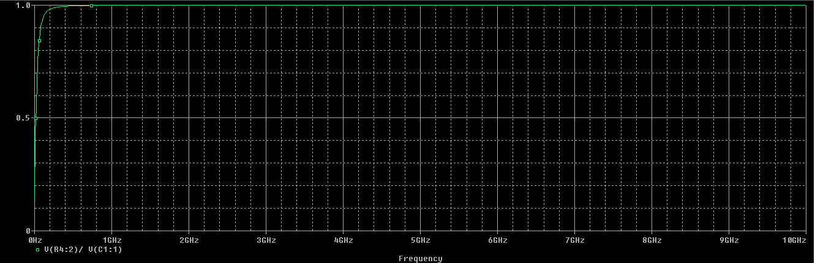CJE = 3pF , VJE = 0.85V , MJE = 0.45, CJC= 3pF , VJC = 0.7V , MJC = 0.35 ), explain the results.

Comments:

* Now the gain became equal to 1 which means that the output is the same as the input which happened since the internal capacitors started to behave as short circuits which means the base voltage is equal to the collector voltage now.



**Good Luck**